Computer Network

HW #2 (30 Points)

Due date : 2014/5/6 (Cyber Campus)

Things to Submit : studentid.c File (All code should be in one file.)

This homework is to implement a simple web browser and server. One program should deal with both the **HTTP Request** and the **HTTP response** message. The server and the client are implemented as a **single application**. It is a **simple extension** of HW1.

The following is an example of execution.

First, run the application “hw2” with different port numbers.

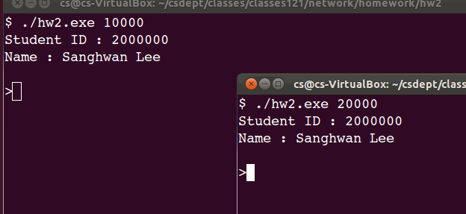

Next, the in the second program (with port number 20000), run the “load” command. You will see that it downloads a.html from the first program.

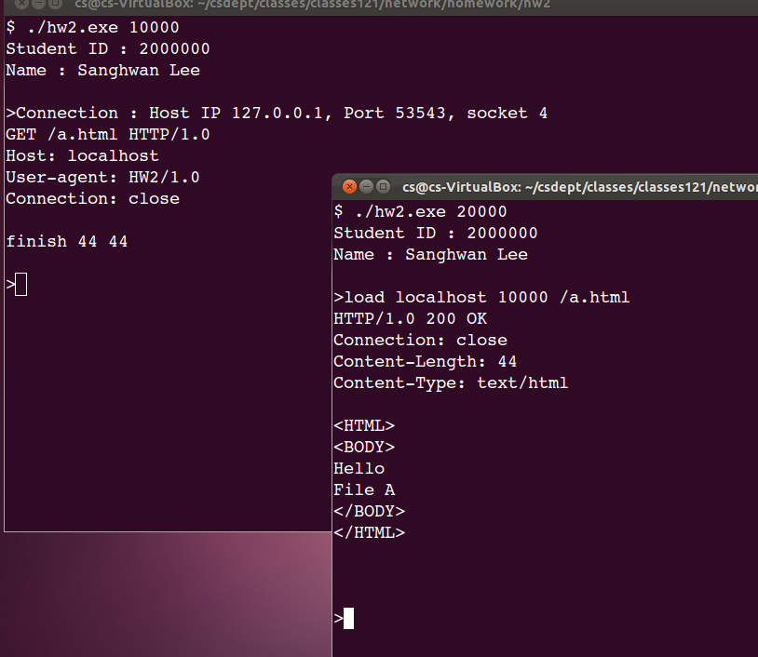

The executable file is hw2.exe.

The command line arguments are the port number at which this application waits for TCP connection request. When the application is executed, a prompt should occur as follows.

>

Users can use 2 commands.

* load hostname portnum /filename : user can request a file from a host with the port number. The file name should be an absolute path starting with “/”. It displays the contents to the screen.
* quit : stop the application

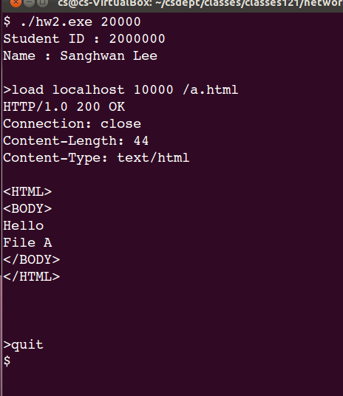

* Commands are case insensitive.

Implementation details

* When the program is executed, the student ID and name should appear just as the above figures.
* The program can only serve the .html files in the current directory of the executable.
* When a user types “load” command, the program generate HTTP request message based on the parameters of the “load” command. In this homework, the **HTTP request** message contains only 4 header lines as shown in the figure.

GET /a.html HTTP/1.0

Host: localhost

User-agent: HW2/1.0

Connection: close

* When the program sends the **HTTP response** message, it contains only 4 header lines as shown in the figure. If the file does not exist, the response code is “404 Not Found”.

HTTP/1.0 200 OK

Connection: close

Content-Length: 44

Content-Type: text/html

After the server part sends the **HTTP response** message, it displays the number of bytes of the file as follows.

finish 44 44

The first number is the number of bytes sent. The second number is the number of bytes of the file. These two numbers should be the same.

The following is an example of “404 Not Found”.

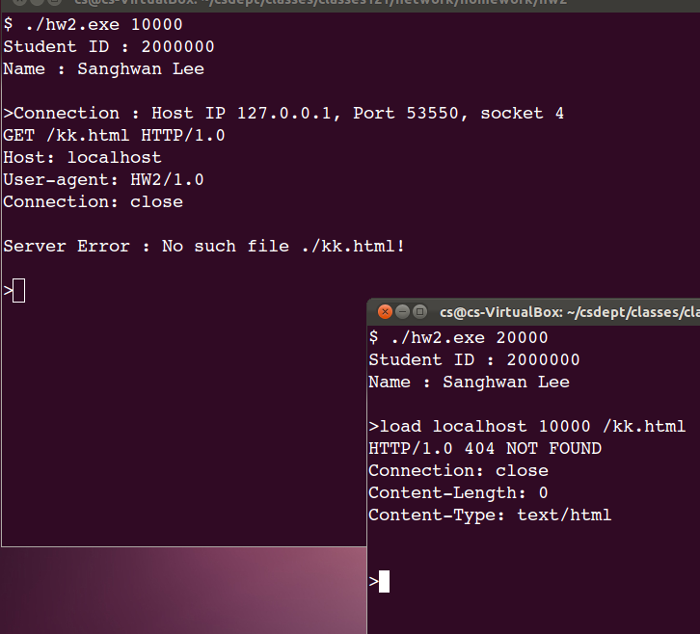

* Actually, the user can request documents from a **real web server**.

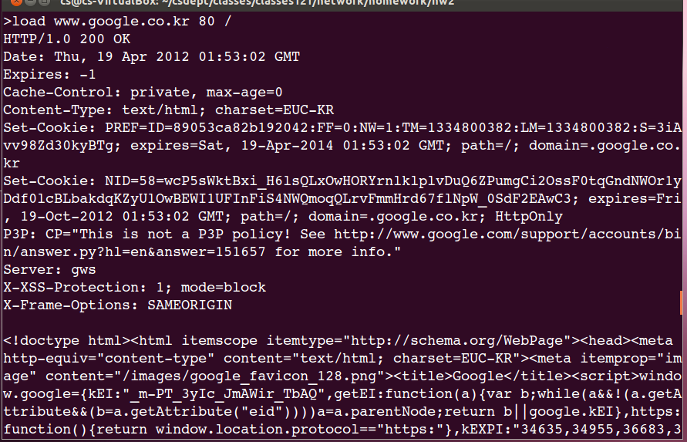

* **A real web browser** can request a file from hw2.exe.

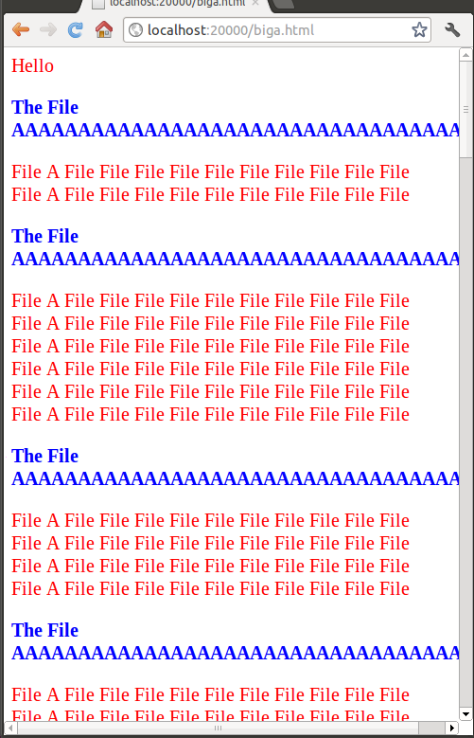

You can see the **HTTP request** message from the Google Chrome browser.

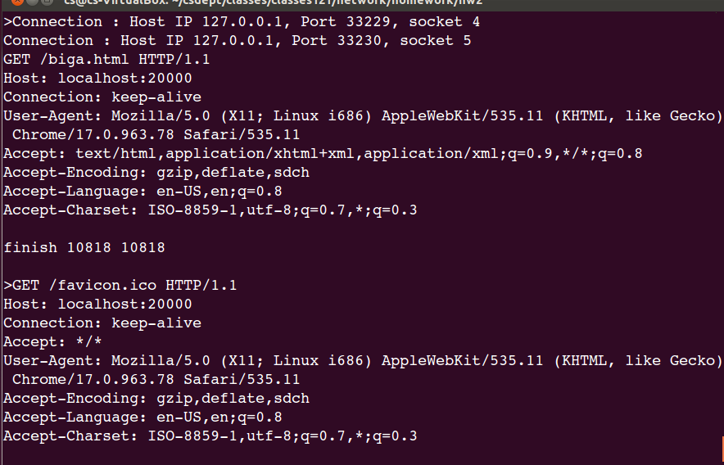

Executable

* An executable is attached so that you can test by yourself.